My Attendance/Participation Success Plan

POSSIBLE STRATEGIES FOR GOOD ATTENDANCE AND PARTICIPATION
Please review the list and choose strategies that fit your daily schedule.
- I will make attending and participating in school every day a priority.
- I will post my class schedule of classes and log in information in a visible location near my desk or on the refrigerator.
- I will set alarms / alerts to remind myself to wake up on time and participate in classes.
- I will try to find a quiet place at home where I can participate in class and complete my school work. If I cannot, I will ask my school or community organization if they have a safe place where I can study and log into class.
- I will keep track of my attendance and absences.
- I will find a relative, friend or neighbor who can help me resolve a problem that is keeping me from attending or participating in school.
- If I am absent, I will contact my teachers to find out what I missed.
- I will keep healthy by wearing a mask, as needed, and getting a flu shot.
- I will set up non-sick medical and dental appointments for weekdays after school. If I must make a non-urgent medical appointment during the school day, I will try to attend school for the majority of the day.
- When I am struggling with a challenge that is keeping me from attending or participating in school, I will confide in an adult at school and seek help.

To improve my attendance/participation, I commit to the following:
1.

2.

3.

Student Signature: Date

Teacher Signature: Date

MY FAMILY’S HELP BANK

CREATE BACKUP PLANS FOR GETTING TO SCHOOL

MY FAMILY

POTENTIAL HELPERS

EVERYDAY HELPERS

OCCASIONAL HELPERS

- My Family:

- Everyday Helpers:

- Occasional Helpers:

- Potential Helpers
My Family: List who lives in your house.
Everyday Helpers: Identify who you can call on for help with attending/participating in school. These are people like friends, neighbors and relatives who can help regularly.
Occasional Helpers: Identify people who probably cannot help every day, but can help in a pinch. Maybe it’s a godparent, a relative or a friend who lives outside your neighborhood but can be there for short stints.
Potential Helpers: Identify people who are part of your school community, place of worship or neighborhood who are able to help—if you ask.

If I need help attending/participating in school, I will ask the following people for help:
Name: Best Contact Number: Name: Best Contact Number: Name: Best Contact Number:

2024-2024 ACADEMIC CALENDAR
Check the days when you showed up to school (whether it was in person, online or involved completing an assignment). Mark absences with an X.
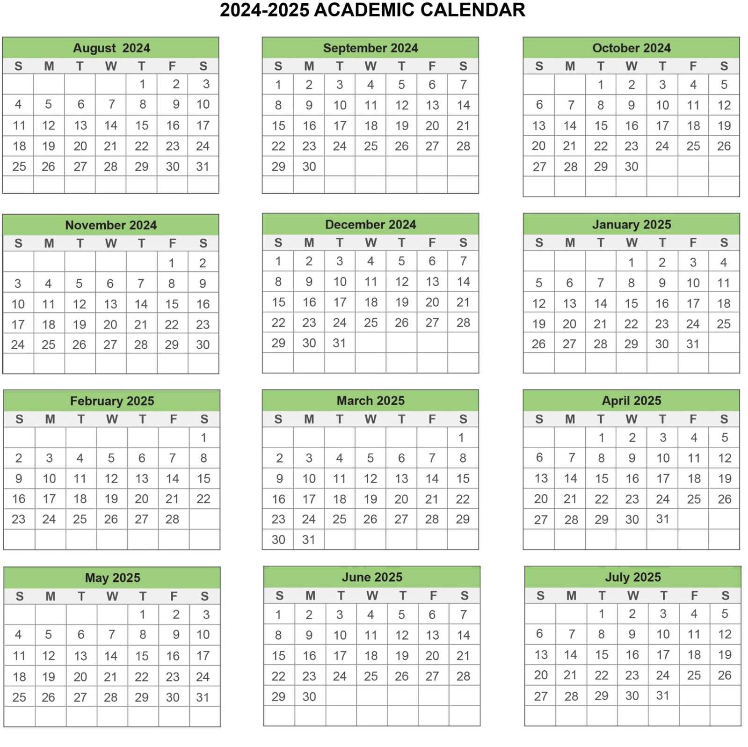

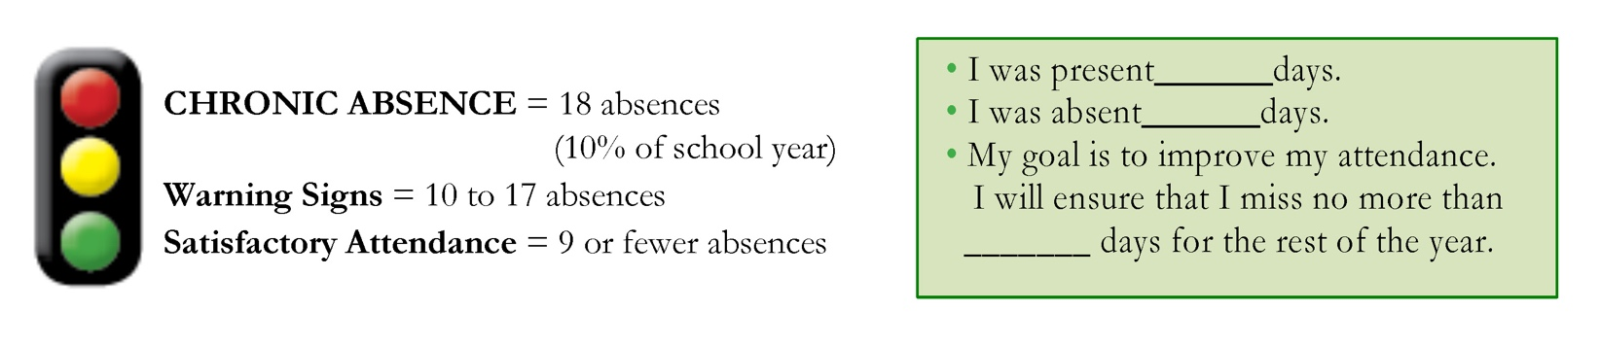
To learn more, please visit www.attendanceworks.org

