

My Child’s Attendance Success Plan

Possible strategies to reach my child’s attendance goals and help my child gain the skills to do well in school and to read by 3rd grade.

- Keep an attendance chart at home to track absences. Consider using the attached calendar.
- At the end of the week, I will recognize my child for attending preschool or kindergarten every day with . (i.e., a visit to the park, a new book, a special treat, a hug. etc.)
- Make sure my child is in bed by p.m. and the alarm clock is set for a.m.
- Find a relative, friend or neighbor who can take my child to or from school if I can’t. I can list who can help on the Help Bank (attached).
- Set up medical and dental appointments for weekdays after school.
- If my child has a slight stomachache, headache or allergies and is not sick with a contagious illness, I will send my child to school. I will call the school or a health provider for advice if my child complains regularly.

To improve ______________________’s attendance, I commit to the following:
- ____________________________________________________________________
- ____________________________________________________________________
To improve ______________________’s attendance, the program commits to:
1. _____________________________________________________________________
2. _____________________________________________________________________
We will review progress to meet this goal in one month.
Family Signature: Date:

Program Signature: Date:

To learn more, please visit www.attendanceworks.org
Adapted from materials created by Early Works at Earl Boyles Elementary School in Portland, Oregon (http://www.childinst.org/our-initiatives/early-works)
rev. October 2025
My Family’s Help Bank
Create Backup Plans for Getting to School

Everyday
helpers
Everyone needs a buddy sometimes.
Plan ahead to make life easier.
My family
Potential helpers
Occasional helpers
- My family: Anyone who lives with you who can help on a regular basis. Avoid using older children if it causes them to miss school.
- Everyday helpers: Nearby friends, neighbors and relatives who might share to and from school duty regularly.
- Occasional helpers: A godparent, relative or friends you might be able to call on once in a while for a special need.
- Potential helpers: Ask your teacher, school, neighborhood organization or place of worship for introductions to others who can occasionally help get students to and from school.

- My family:
- Everyday helpers:
- Occasional helpers:

- Potential helpers:
If I need help getting my child to and from school, I will ask the following people to be our backup:

Name: Best Contact Number:
Name: Best Contact Number:

Name: Best Contact Number:
October 2025 www.attendanceworks.org
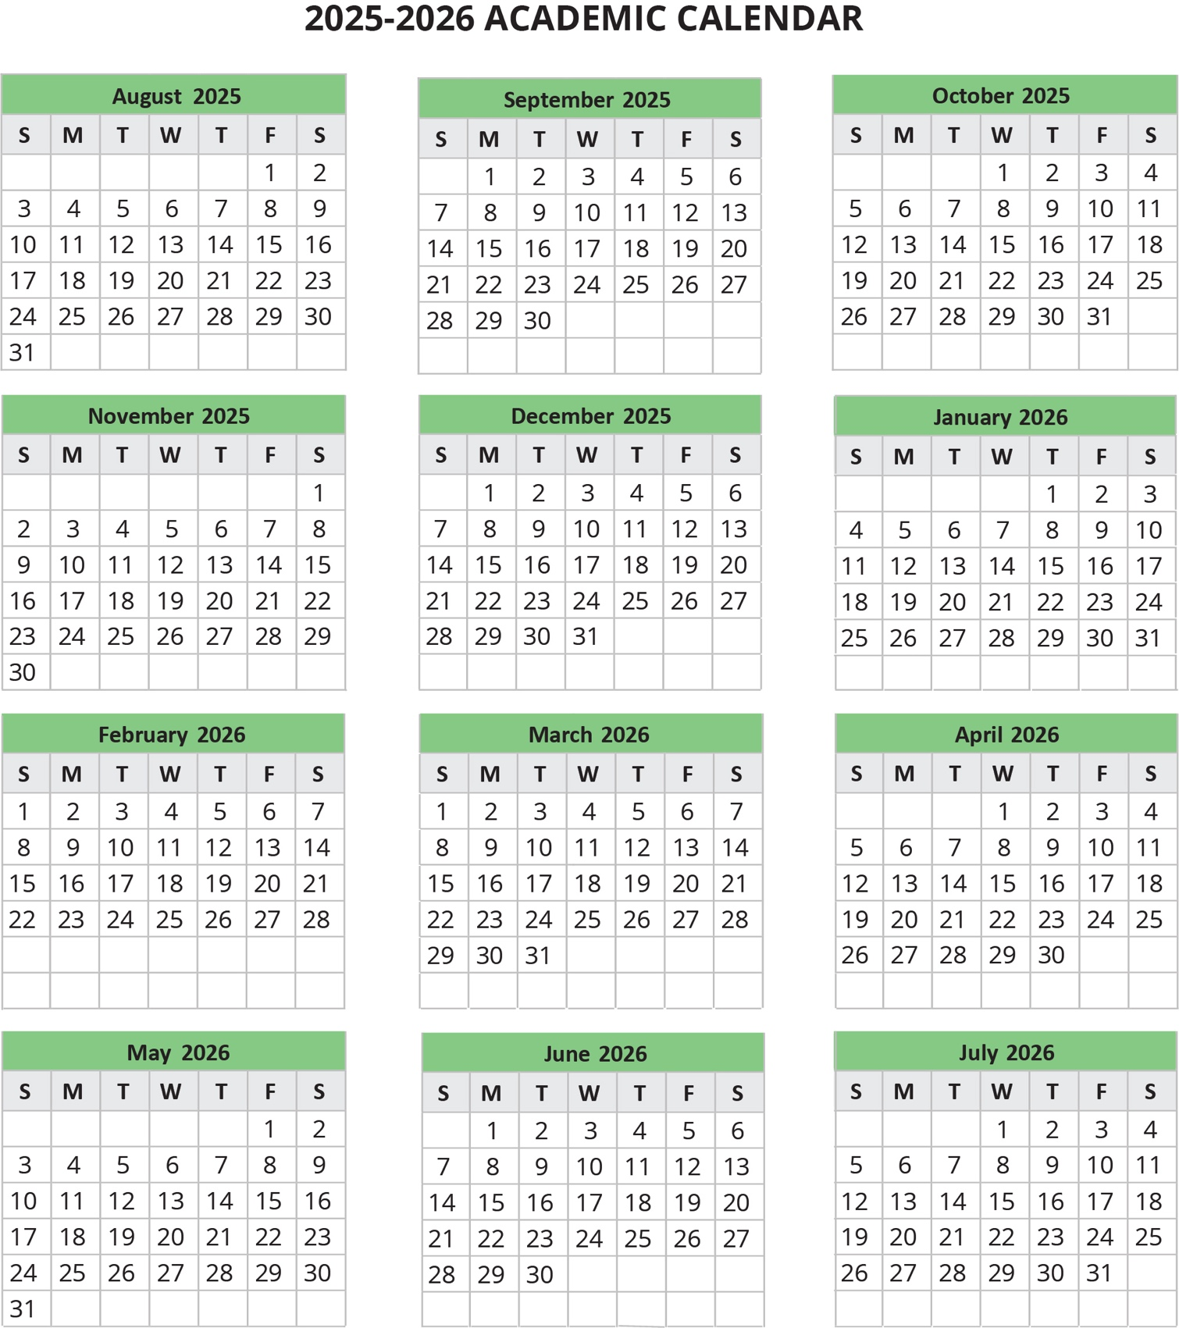

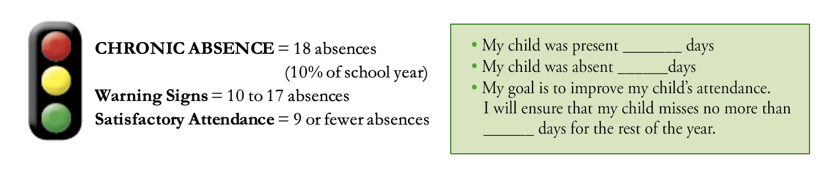
Note: These numbers assume a 180-day school year.

