

**Utah: *Illustrating the Power of Education and Awareness Building Across Multiple Sectors to Inspire Action***

***State Context:***

Known for its vast deserts as well as its towering mountains, Utah is the 10th least densely populated state in the country. More than a third of its population resides in the Salt Lake City metropolitan area. It is also a relatively young state, with 31% of the population under 18 years old[1], and it has the highest birth rate in the nation—17.4%, compared with the national average of 12.5%[2]—contributing to its status as one of the fastest-growing states in the country.

Of Utah’s 612,434 K-12 students, the vast majority are white (75.9 %), with Hispanic/Latino students (16.3%) making up the next-largest racial/ethnic group. Other student populations are: 2.2% Multiracial, 1.7% Asian, 1.5% Pacific Islander, 1.3% black and 1.1% American Indian.[3] About 16% of the state’s children are from immigrant families, most of whom hail from Latin America (62%), and in 2013 13% of children spoke a language other than English at home.[4]

In 2013, Utah had an 83% high school graduation rate. Low-income students, however, were substantially less likely to graduate than their more affluent peers (72.9% compared with 87.4%). Utah fourth graders read at a slightly higher level than the national average (37% of fourth graders scored at or above proficient in reading, compared with 34% nationwide).

Statewide, 37% of students are eligible for the federal free and reduced-price meals program, and 14.6% of children in Utah live in poverty, as defined by the federal poverty threshold. Utah children come from relatively well-educated households: 91% live in homes where the household head has a high school diploma/GED or higher, compared with the national rate of 86%.[5]

There are 1,069 schools in Utah, organized within 41 districts. The five districts in Salt Lake County enroll the largest number of students.[6]

**Make the Case:***How did chronic absence become a priority? Who helped make the case? How?*

Utah’s journey to reduce chronic absence illustrates how interest that begins with one sector—in this case, the afterschool community—can expand to a range of key stakeholders and ultimately spur statewide awareness and interest in reducing chronic absence. It demonstrates the value of building understanding about why chronic absence matters, so that using the metric is not seen as a government mandate but as a common-sense tool for action for schools, communities and families. This up-front investment in educating stakeholders about the value of chronic absence as a metric has been essential in a state that prizes local control and the right of families to determine how their children are educated.

***Utah’s afterschool community initiates conversations about chronic absence***In early 2010, the Utah Afterschool Network ([UAN](http://www.utahafterschool.org/)) joined counterparts in two other states (Maryland and Pennsylvania) in a two-year, Mott Foundation-funded project aimed at building capacity of afterschool providers to address chronic absence. UAN is a nonprofit organization established in 2005 by a consortium of more than 100 afterschool practitioners, youth advocates and leaders of state agencies including the state Office of Education. Attendance Works, the technical assistance provider, helped UAN learn about chronic absence, understand its value for enhancing collaboration with schools, and identify barriers and opportunities to monitoring chronic absence. A survey of practices at 124 afterschool programs revealed that while they had attendance data for their own programs, very few had access to information about school- day attendance for the students they served.

***University of Utah documents the scale and impact of chronic absence***UAN’s annual conference in 2010 highlighted the issue of chronic absence and inspired the Utah Education Policy Center (UEPC), based at the University of Utah, to find out the scale, scope and impact of chronic absence. Leveraging a federal grant that supported the development of Utah’s longitudinal student data system, UEPC produced [Chronic Absence in Utah Public Schools](http://www.attendanceworks.org/wordpress/wp-content/uploads/2014/04/UTAH-Chronic-AbsenteeismResearch-Brief-July-2012.pdf) in July 2012. A compelling picture of why chronic absence matters, the study revealed that one out of seven students in Utah is chronically absent. On average, a student was nearly 13 times more likely to be chronically absent if he or she had missed that much school in the prior year. Each year of chronic absence between eighth and 12th grade doubled the likelihood that a student would drop out. Subsequent research found that chronically absent high school students are less likely to enroll and stay in college.

***Pioneering work emerges among local school districts and communities***Even before the statewide research was published, several local districts (Ogden, Salt Lake City and Granite) began using their own data to examine if chronic absence was a problem and to work with partners to find solutions. In Salt Lake City Schools, Superintendent McKell Withers and his team quickly discovered that seemingly good average daily attendance (93-95%) was masking high levels of chronic absence, especially in some schools. School administrators made attendance a priority and built in real-time data tools to identify students before they became chronically absent. In Ogden, then-Superintendent (and now chief state school officer) Brad Smith and his team partnered with the United Way of Northern Utah to analyze data and share the implications with an array of community stakeholders, ranging from local service providers to religious leaders. As part of advancing a collective approach to community problem-solving, the United Way of Salt Lake helped Granite analyze its data and offer professional development to school staff.

***Voices for Utah Children explores chronic absence as an indicator of well being***   
Early in this journey, Voices for Utah Children, a nonprofit child advocacy organization and the state’s Annie E. Casey Foundation Kids Count grantee, began exploring the use of chronic absence in elementary school as a statewide indicator of child and family well-being. In 2012, Voices used its annual luncheon to introduce the idea to key constituents and selected policymakers. In 2014, Voices issued [Attendance and the Early Grades: A Two Generation Issue](http://www.utahchildren.org/newsroom/item/517-attendance-and-the-early-grades-a-two-generation-issue), which makes the case that “improving student attendance is an essential, cost-effective but overlooked two-generation strategy for ensuring students are on track to learn and succeed and to decrease the chance of living in poverty as adults.” Chronic absence statewide and by district is now a recurring metric in the annual Utah Kids Count Data Book.

***Governor Herbert Proclaims September as Attendance Awareness Month***   
By 2013, Governor Gary R. Herbert had become involved in raising awareness. He produced this public service announcement and [issued a proclamation](http://awareness.attendanceworks.org/wp-content/uploads/Governors-Declaration-Sept-Attendance-Awareness-Month.pdf) [t](http://awareness.attendanceworks.org/wp-content/uploads/Governors-Declaration-Sept-Attendance-Awareness-Month.pdf)h[a](http://awareness.attendanceworks.org/wp-content/uploads/Governors-Declaration-Sept-Attendance-Awareness-Month.pdf)t he continues to re-issue annually.

***Utah State Office of Education begins convening key stakeholders***   
In 2013, the Utah State Office of Education (USOE) asked the Regional Educational Laboratory West (REL West) to help organize a forum on chronic absence as part of the REL’s support to Utah on dropout prevention. This effort also involved the National Dropout Prevention Center for Students with Disabilities (NDPC-SD). Timed to coincide with Attendance Awareness Month in September, this 2013 event provided an opportunity to introduce the concept of chronic absence to districts throughout Utah, examine local attendance data and promote the idea of using chronic absence as an early warning sign of academic trouble in order to provide targeted support to students and their families. The event emphasized the importance of prevention and not jumping to a punitive legal approach. After the event, USOE established the Chronic Absence Committee drawn from the agency staff, other state agencies and nonprofit community organizations. The group meets periodically to share updates and generate ideas for raising awareness and disseminating research and practice ideas.

In 2014, the USOE brought together key partners at a conference for policymakers. As described in this [press release](http://schools.utah.gov/main/INFORMATION/Online-Newsroom/DOCS/2014/AttendanceAwareness.aspx), the conference sought to increase knowledge and identify who could advance the work through state- and district-level policies and practices as well as community partnerships. An important result of this work is that practices to reduce chronic absence have continued to spread, especially as local districts incorporate chronic absence into their early warning systems and data dashboards.

**Map Chronic Absence:** *Which students, schools and districts appear to be most affected by chronic absence? How much is it a problem in the early grades? Is chronic absence information shared? If so, how?*

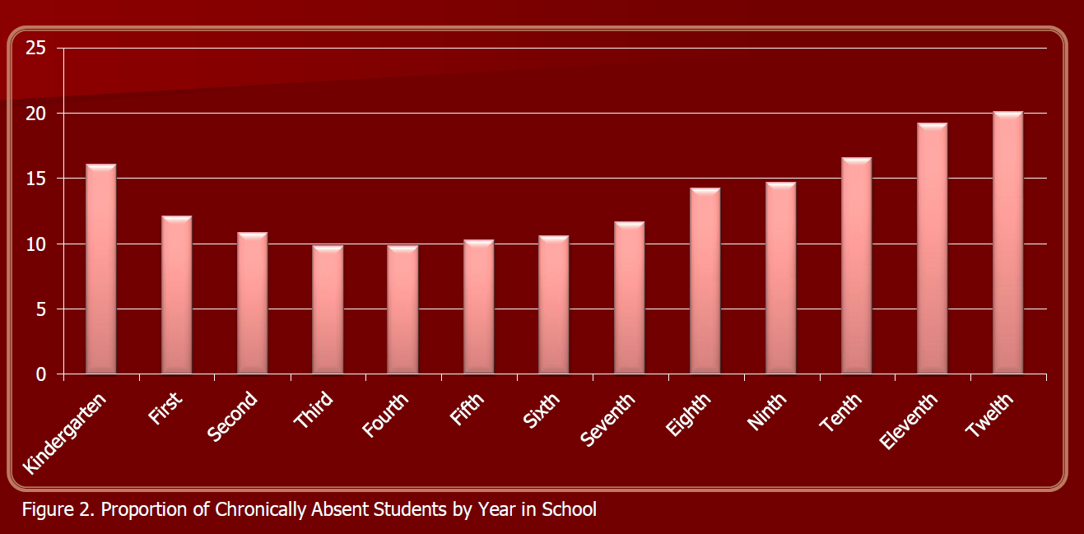According to [Chronic Absence in Utah Public Schools](http://www.attendanceworks.org/wordpress/wp-content/uploads/2014/04/UTAH-Chronic-AbsenteeismResearch-Brief-July-2012.pdf), problematic attendance is high in kindergarten, decreases in later elementary grades and then increases starting in eighth grade, with the highest level in 12th grade.

State data confirm data from the National Assessment of Educational Progress, showing that students who are low-income, identified as being in special education, or are racial minorities are more likely to be chronically absent.

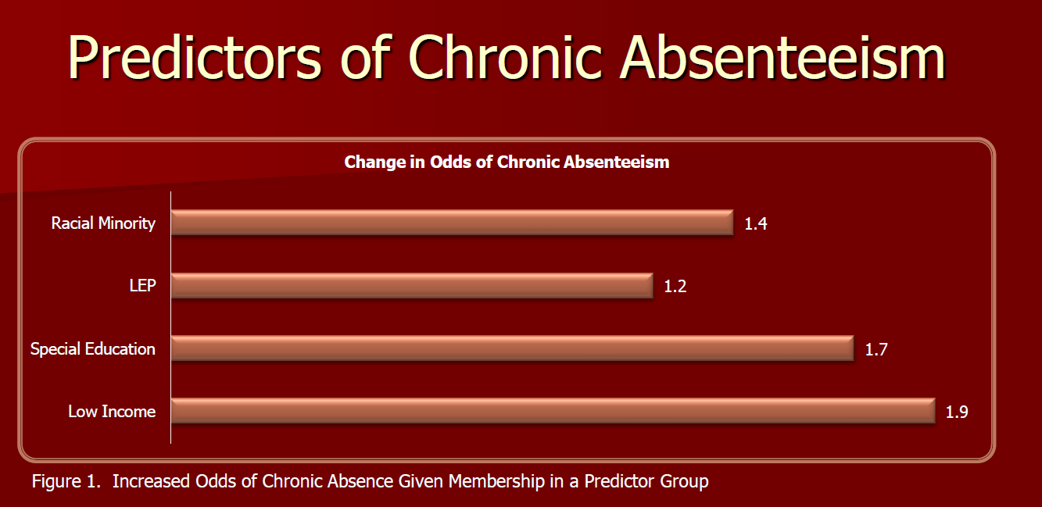

State data also demonstrate the importance of keeping in mind the overall demographic of Utah when considering how to tailor resources to address the needs of chronically absent students. Similar to the demographics of the state as a whole, the largest number of chronically absent students are white, English-speaking students who are not enrolled in special education.

Currently, the best ongoing source of information about rates of chronic absence across the state is the annual [Utah Kids Count Data Book](http://www.utahchildren.org/images/pdfs/2015/2015_Utah_KIDS_COUNT_Data_book_5-7-15.pdf). It shows chronic absence by district along with total enrollment, proportion of students receiving free and reduced-price meals, and pupil-teacher ratios.



**Unpack Chronic Early Absence:** *What is known about factors that contribute to chronic early absence? What is known about health-related factors?*

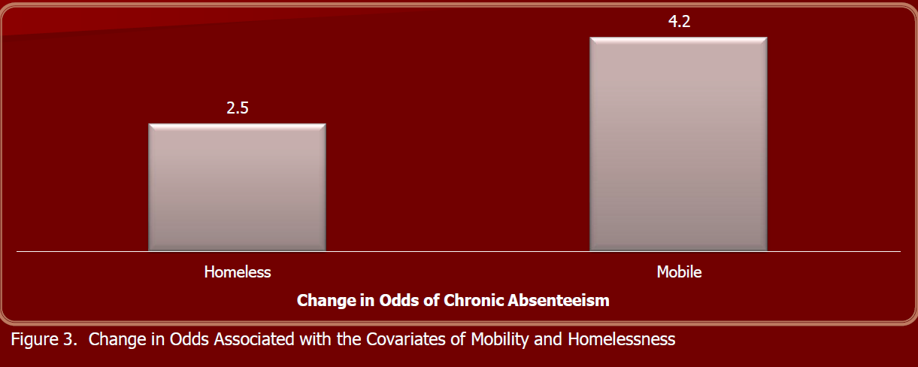Utah is still in the early phases of unpacking the causes contributing to chronic absence. Statewide data analyzed by the UEPC suggests that poverty is a major factor. Children who received free and reduced-price meals 1.9 times more likely to be chronically absent than their more affluent peers. Chronic absence was 4.2 times more likely for students who were highly mobile, and 2.5 times more likely for homeless students. Research even showed that the type of homelessness influenced levels of chronic absence.

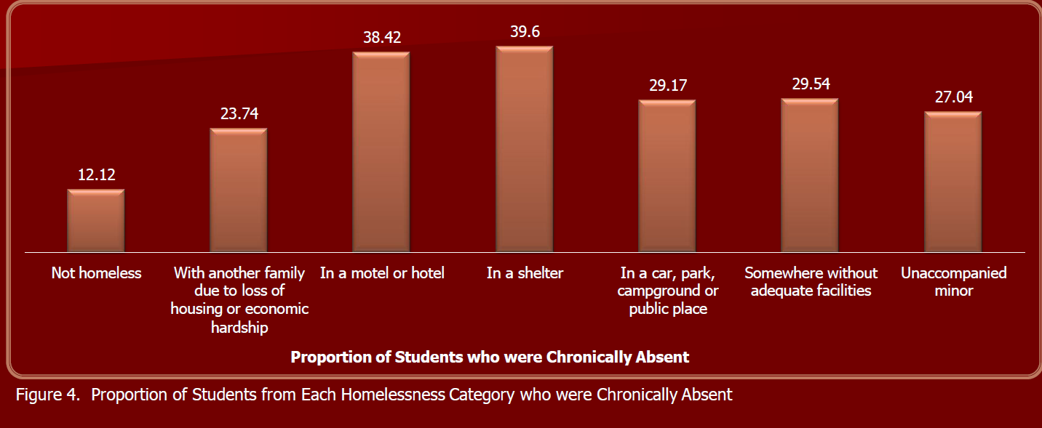Overall, the state of Utah appears to have relatively lower levels of health challenges, commonly recognized as contributing to chronic absence. Asthma rates are lower in Utah (6% versus 9% nationwide). According to 2013 Current Population Survey estimates, access to dental and health care in Utah is generally on par with national rates. In Utah, 78% of children receive preventive dental care, compared with 77% nationwide. Only 10% of Utah children do not have health insurance, compared with 9% nationwide.[7] However, local health conditions can vary significantly across the state. Further exploration at the county or school district level may reveal health challenges that need to be addressed in order to reduce chronic absence.

**Learn from Positive Outliers***: Have positive outliers been identified? How do they inform our work?*

Little is available about insights gained from positive outliers, as Utah is still early in the process of finding out about and documenting lessons learned from districts and schools with lower-than-expected levels of chronic absence.

**Embed Action into Existing Work and Initiatives:** *How can relevant reforms and cross-sector initiatives be leveraged to promote action?*

In Utah, several initiatives offer important opportunities for embedding attention to chronic absence. These include:

**Intergenerational Poverty:** Due to legislation passed in 2012, Utah has an [Intergenerational Welfare Reform Commission](https://jobs.utah.gov/edo/intergenerational/igp5_10yearplan.pdf) comprised of the executive directors of the state agencies serving Utah families: the departments of Workforce Services, Health, and Human Services; the superintendent of the Utah Office of Education; the state juvenile court administrator; and the chair of the Intergenerational Poverty Advisory Committee. The purpose of the commission is to collaborate in sharing and analyzing data regarding intergenerational poverty and use this information to implement policies and programs that increase the number of children who can break the cycle of poverty and welfare dependency by the time they become adults. Establishing a standard definition of absences across all counties is one of the recommendations currently being considered by the commission.

**Early Warning Systems and Data Dashboards:**As districts develop early warning systems and data dashboards, they can and should incorporate chronic absence as a measure. With the help of REL West, this is already starting to happen, particularly in the technical assistance they offer to high schools. A key consideration is looking at how chronic absence could be built in as an early warning of academic trouble starting in elementary school.

**Multi-Tiered Systems of Support:**USOE already has a rich framework and set of resources (both tools and coaching) available to help local education agencies implement Multi-Tiered Systems of Support. Online resources can be found [here](http://www.schools.utah.gov/umtss/default.aspx). As in other states, this framework could be expanded to pay more explicit attention to data on chronic absence and offer guidance about how to incorporate attendance practices into the different tiers.

**School Transformation/Improvement:**USOE is also exploring how it can provide resources and tools to improve attendance as part of the technical assistance it offers to priority and focus schools receiving supports through federal School Improvement Grants.



Download the full report: *Mapping the Early Attendance Gap: Charting a Course for School Success*

**http://www.attendanceworks.org/research/mapping-the-gap/**

1. U.S. Census Bureau: State and County QuickFacts. Data derived from Population Estimates, American Community Survey, Census of Population and Housing, State and County Housing Unit Estimates, County Business Patterns, Nonemployer Statistics, Economic Census, Survey of Business Owners, Building Permits. Last Revised: Wednesday, Aug. 5, 2015, 09:23:31 EDT.
2. <http://www.cdc.gov/nchs/data/nvsr/nvsr64/nvsr64_06.pdf>
3. (<http://www.schools.utah.gov/data/Fingertip-Facts/2015.aspx>)
4. National Kids Count
5. Measures of Child Well-Being in Utah 2015 (<http://www.utahchildren.org/images/pdfs/2015/2015_Utah_KIDS_COUNT_Data_book_5-7-15.pdf>)
6. <http://www.schools.utah.gov/data/Fingertip-Facts/2015.aspx>
7. National KIDS COUNT