******­­

**Rhode Island: *Driving with Data!***

***State Context:***

Rhode Island is the smallest state in the country in terms of geographic area but the second most densely populated. In 2014, Rhode Island had 141,918 students in grades preK-12. The majority of students (62%) were white. Hispanics made up the next largest ethnic group, at 23%; 8% of students were black, 3% were Asian, 3% were multiracial and 1% were American Indian. Approximately 23% of Rhode Island’s students speak a language other than English at home; for nearly 70%, that language is Spanish.

Rhode Island schools are organized into 66 public Local Education Agencies (LEAs), including 32 traditional school districts, four regional school districts, and charter and state-operated schools. Rhode Island has 36 school districts and 300 schools, not counting an additional four state schools and 25 charters.

In 2014, Rhode Island had an 80.7% four-year high school graduation rate. Low-income students, however, were substantially less likely to graduate (71.1%, compared with 92.8% of their more affluent peers.[1] About 38% of fourth graders were at or above grade-level proficiency in reading, compared with 34% nationally.

Approximately 21.5% of children under 18 in Rhode Island live in poverty. In 2010, two-thirds (67%) of minority children lived in one of the state’s four core cities—Central Falls, Pawtucket, Providence and Woonsocket—which had the highest percentage of children living in poverty. In 2010, more than four-fifths of the children in Providence (84%) and Central Falls (87%) were from communities of color, predominantly Hispanic and black.

Between 2009 and 2013, 39% of the parents of newborns statewide had a high school diploma or less. In 2013, 94.6% of Rhode Island’s children under age 18 had health insurance, ranking No. 16 in the nation. The state’s RIte Care program was recently named the No. 1 Medicaid managed-care children’s health insurance program in the country in terms of quality of care. In 2012, 89% of children in Rhode Island had dental insurance that paid for routine dental care, up from 73% in 2001. This increase resulted from the establishment of RIte Smiles, a Medicaid, managed-care dental insurance program that has significantly increased the number of dentists who treat children covered by Medicaid.

**Make the Case:***How did chronic absence become a priority? Who helped make the case? How?*

The Rhode Island chronic absence journey illustrates the power of combining pioneering local work with an effective “inside/outside” partnership. They key partners are the state Department of Education, which provides engaged leadership and a robust data system, and Rhode Island KIDS COUNT, the statewide children’s policy and advocacy organization, which is skilled at combining good data and press coverage to inspire action across the state. Rhode Island’s experience also reveals the tremendous importance of taking an interagency approach, especially in high-poverty districts with significant challenges in getting children to school.

Pioneering local work reveals that chronic absence from school is a problem that is solvable. In 2008, Providence began working on chronic absence through its participation in the Annie E. Casey Foundation’s Making Connections neighborhood initiative. The foundation commissioned the initial research that identified poor attendance as a factor contributing to the lack of third-grade reading proficiency; analyzing chronic absence in the focus school, Bailey Elementary, was a component of the initiative’s data-driven approach. The school offered concrete insights into how chronic absence could be addressed. For example, community health workers reaching out to parents of chronically absent Bailey students discovered that many of these absences were due to parents working the night shift and falling asleep before getting their children to school. Bailey addressed the problem by using a federal Full-Service Community Schools grant to launch a before-school breakfast program.

By 2011-12, Providence schools began calculating chronic absence district-wide in order to inform their community schools effort. The data, revealing a 37% district-wide rate of chronic absence, was picked up by the local press and further generated awareness that student absenteeism is major challenge. Reducing chronic absence soon became a key focus of the Providence Children and Youth Cabinet. During this same time period, the national Campaign for Grade-Level Reading was publicizing the importance of reducing chronic absence as a critical strategy for increasing the percentage of low-income children reading at grade level by the end of third grade.

The Providence cabinet, which also oversees the Providence Campaign for Grade-Level Reading (Providence Reads), formed a chronic absence working group of 25 volunteers charged with taking a data-driven approach to reducing chronic absence. The working group supported city-wide messaging efforts combined with in-depth work with six schools that formed their own school attendance teams to advance the project. As a result of this effort, there were reductions in chronic absence in all six schools. In several schools, City Year national service volunteers have played a key role by helping with outreach and support to students with a prior history of chronic absence. Safe Routes to School has also been instrumental in starting “walking school buses,” coordinated by Family Service of Rhode Island, to create a culture of attendance as well as address neighborhood safety concerns. As the work has progressed, the Providence Children and Youth Cabinet has also begun to delve in depth into the health-related causes of chronic absence.

Statewide interest was generated through documentation of scale, scope and impact.

Not long after the work began in Providence, Rhode Island KIDS COUNT drew upon this local experience and the report [Present, Engaged and Accounted For](http://www.nccp.org/publications/pub_837.html) to add chronic early absence as an education metric to its [2010 Rhode Island KIDS COUNT Factbook](http://rikidscount.org/Portals/0/Uploads/Documents/2010%20Rhode%20Island%20Kids%20Count%20Factbook.pdf).

The factbook is released annually at a high-profile breakfast event attended by more than 500 community leaders as well as all of the state’s top elected officials and policymakers. This move allowed all stakeholders in Rhode Island to see rates of chronic absence for grades K-3 and middle and high school grades statewide and for each district, including the four core cities. The factbook narrative defined chronic early absence and explained how it differs from average daily attendance and its significant impact on academic success. Updated each year, the factbook provides an ongoing mechanism for creating public accountability for taking steps to reduce chronic absence.

Building on their close partnership, Rhode Island KIDS COUNT and the Rhode Island Department of Education (RIDE) work together to engage in deeper data analysis and convene stakeholders to promote learning and action. In September 2014, for example, they, together with the Providence Plan and the Rhode Island Data Sharing Project, joined forces to hold an event calling attention to the adverse consequences of kindergarten chronic absence. At this event, they released a Rhode Island KIDS COUNT Early Learning Fact Sheet: [Focus on Reducing Chronic Early Absence](http://www.rikidscount.org/Portals/0/Uploads/Documents/RIKC%20Early%20Learning%20Fact%20Sheet%20-%20Chronic%20Absence.pdf), and the RI DataHub released its data story, [Chronic Absenteeism Among Kindergarten Students](http://ridatahub.org/datastories/chronic-absenteeism-in-kindergarten/1/).

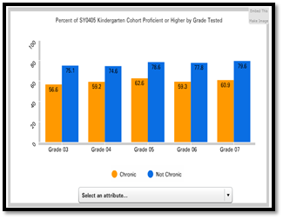

The compelling findings revealed that chronically absent kindergartners were:

* 20% less likely to score proficient or higher in reading
* 25% less likely to score proficient or higher in math
* twice as likely to be retained in grade
* twice as likely to be suspended by the end of seventh grade
* more likely to continue being chronically absent

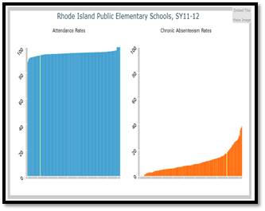

The brief also made clear that high levels of chronic absence were being masked if attention was paid only to average daily attendance and truancy.

The sharing of data, along with various opportunities to share lessons about what works across districts in Rhode Island, has led to a growing number of districts embarking on their own local initiatives to improve attendance.

**Map Chronic Absence:***Which students, schools and districts appear to be most affected by chronic absence? How much of a problem is it in the early grades? Is information on chronic absence shared? If so, how?*

In Rhode Island, chronic absence data are widely shared and publicly available. As mentioned earlier, the data is published each year statewide and by district in the education indicators section of the [Rhode Island KIDS COUNT Factbook](http://www.rikidscount.org/Portals/0/Uploads/Documents/Factbook%202015/Education/EducationSection-2015FB.pdf) (page 151). The two indicators (one for K-3, the other for middle/high school) report the chronic absence data for the state as a whole, for the four core cities with concentrated childhood poverty, and for each of the state’s 36 school districts. Equally important, [Infoworks](http://infoworks.ride.ri.gov/state/ri),the education data reporting system maintained by RIDE, includes chronic absence as an indicator of safe and supportive schools.

A deeper analysis of the data conducted for *Mapping the Early Attendance Gap* offers additional insights about who is chronically absent and when those patterns occur. Chronic absence is not only high in the early grades, it is much higher for children from low-income families and students with disabilities (see charts below). On average, chronic absence rates are 17 percentage points higher for students from low-income families than for those from higher-income families, and chronic absence rates for students with disabilities are 9 percentage points higher than for students without disabilities.

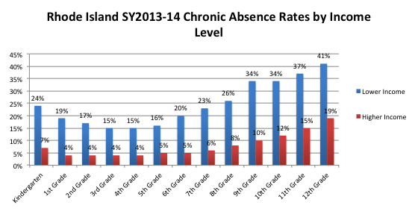

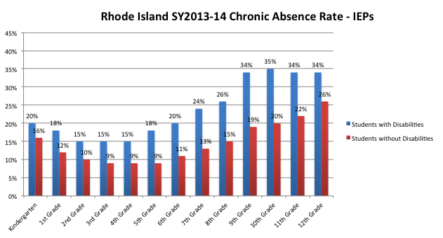

In Rhode Island, the overall rate or percentage of children chronically absent was generally highest for Hispanic (26%) and American Indian (28%) students. These two groups also had the highest percentage of chronic absence in kindergarten, first and second grades, with black students having the third-highest level in the early grades.

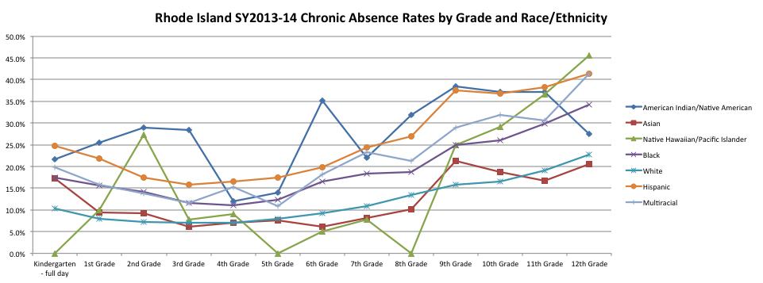

However, just looking at percentages is insufficient, given the varying sizes of the ethnic populations represented. In fact, as the chart below reveals, the largest number of students who are chronically absent are white students, who still make up the majority (62%) of Rhode Island’s students. In the 2013-2014 school year, 10,736 white students were chronically absent, compared with 8,629 Hispanic, 2,248 black and 256 American Indian students (preK-12th grade figures include students enrolled in full-day, state pre-k programs, preschool special education programs and kindergarten programs, who are not depicted in the chart below).

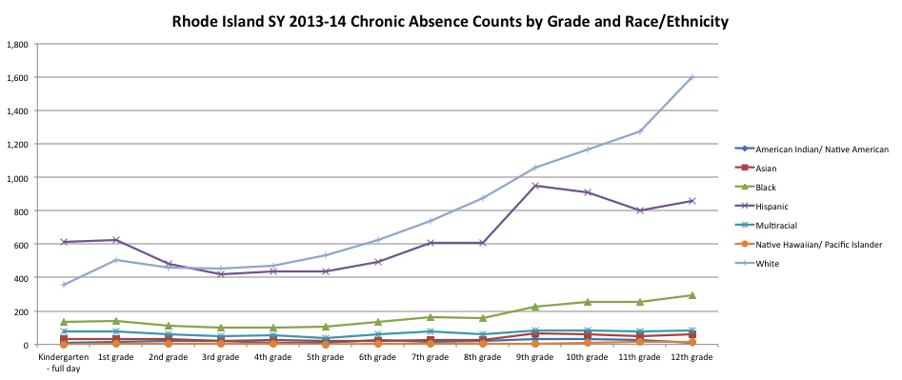

Looking at chronic absence by numbers as well as overall rates is also important when analyzing data by school and district. Consider [Table 50](http://www.rikidscount.org/Portals/0/Uploads/Documents/Factbook%202015/Education/Ind66-ChronicEarlyAbsence-2015.pdf) in the Rhode Island Kids Count Factbook, which shows that some districts may have high rates of chronic absence in the early grades despite having total numbers of chronically absent students that are relatively small compared with those of larger districts.

**Unpack Chronic Early Absence: What is known about factors that contribute to**

**chronic early absence? What is known about health-related factors?**



In Providence, an early exploration of the data found that many struggling readers are chronically absent, have asthma and live in old housing, which is associated with asthma and elevated blood lead levels. The findings appear in[*The Educational Costs of Unhealthy Housing*](http://ridatahub.org/datastories/educational-costs-of-unhealthy-housing/1/)*,* published by the Rhode Island DataHub, and helped the Providence Children and Youth Cabinet secure a grant of up to $1 million over four years from the Rhode Island Health Department. The grant will allow the cabinet to implement evidence-based programs addressing root causes of chronic absence, including anxiety, depression and delinquency among children in low-income neighborhoods. Providence data show that nearly 14% of the city’s kindergartners have a history of elevated blood lead levels, compared with the Rhode Island average of 8.5%.

Matthew Billings, Providence Children and Youth Cabinet project manager, explains that “citywide, we have a chronic absence crisis” but it is more acute in struggling neighborhoods with crumbling homes. “Our kids live there, the asthma comes from there, the lead comes from the pipes, soil and water.”

**Learn from Positive Outliers:** *Have positive outliers been identified? How do they inform our work?*

The work in Providence has inspired action in other Rhode Island cities.

**Central Falls**

Central Falls has been working to reduce chronic absence for a number of years and has found that parents are important partners in the work. For example, officials have found that having parents in the schools greeting students as they enter the building builds on existing relationships and fosters regular attendance. Last year, in 2014, Central Falls established a community collaborative designed to tackle chronic absence in the city’s public schools. This collaborative’s [Back to School Campaign](http://www.centralfallsri.us/central_falls_to_launch_new_back_to_school_program) was led by City Councilwoman and School Committee Member Stephanie Gonzalez and involved school, community and municipal partners. The goal of the campaign was to promote the importance of school attendance, and it included home visits targeting students with a history of chronic absence.

**Newport**

In December 2013, Newport established a [Chronic Early Absence and Truancy Reduction Initiative](http://newportpartnership.org/wp-content/uploads/2015/03/CRM-information-CEATRI1.pdf) that brings together school and community stakeholders along with parents to work together to address the issue. This effort, supported by funding from the van Beuren Charitable Foundation, is allowing the community to use data to identify where problems exist and to use a three-tiered approach to provide chronic absence prevention for all students, more intensive supports for at-risk students, and personalized, targeted supports for the highest-risk students.

**Cranston**

In nearby Cranston, then-Superintendent Judith Lundsten developed the Attendance Counts! Task Force in Spring 2014 with 30 members from all sectors of the community. The task force developed a multi-year plan to educate everyone about the importance of school attendance and use data to identify and support families. Susan Buonanno, principal of Gladstone Elementary School and a member of the task force, illustrates the types of practices that have proved effective at the school site level.

Buonanno knew that absenteeism was a problem for her school. When she started instituting some simple incentives she learned about on the task force, “we saw a huge change,” she says. Every day she announces the class with the best attendance on the intercom. She posts attendance bar graphs and holds monthly challenges, with the winning classes receiving extra recess or freeze pops. In January, when snow and the flu season make it tougher to get to school, she challenges individual students to improve attendance.

Beyond these universal approaches, Buonanno and her staff scour attendance data to look for students who are missing too many days. She calls parents and sends notices home. She also motivates the children. She once pulled together a group of 15 to 20 students who were consistently tardy and talked to them about the importance of showing up on time. She also offered incentives from the school store, where children can purchase items ranging from pencils to a lunch with the principal. Their attendance improved. “I couldn’t mobilize the parents,” she recalls, “so I mobilized the kids, and they mobilized the parents.”

Buonanno has what might be considered a challenging student population: her school serves 584 students, many of whom come from low-income families and are still learning English. She lines up her oldest students to greet ELL students when they come in the door. This creates a welcoming environment for the students and the chance to practice an English greeting. Overall, she finds that her ELL population is committed to attendance. “The families are so respectful of education. There is such a value and importance placed on it,” she says. She sees it as her job to make sure that students are there.

The experiences in all of these communities illustrate how it is possible to turn chronic absence around through a comprehensive approach that starts with engagement of children and their families. Good practice, however, is much more likely when school sites have access to actionable data; the opportunity to learn about effective practices for reducing chronic absence, especially from peers facing similar challenges; and support from community agencies that can help address known barriers to attendance.

 **Embed Action into Existing Work and Initiatives:** *How can relevant reforms and cross-sector initiatives be leveraged to promote action?*

**Data Sharing Partnerships:** Rhode Island has well-established data reporting systems that aim to provide transparent access to a comprehensive set of school-level and district-wide data. Data-sharing agreements and strong cross-agency partnerships ensure that school-level data can be matched to other vital sets of data, including health and post-secondary achievement. Providing stakeholders and the community with accessible information regarding chronic absenteeism across the state allows for a broad coalition of partners to address the most critical areas of need. Efforts to address chronic absenteeism have come from a variety of state, regional and community-based organizations.

**School Transformation Process:** Rhode Island’s data reporting systems are supported by comprehensive state policies and strategies that further highlight and seek solutions to resolve early chronic **absence**. RIDE requires the lowest performing schools in the state transformation process to review their attendance data quarterly and develop a plan to improve attendance as part of their school improvement plans. State officials believe that requiring solutions in schools with the greatest need, often in communities of the greatest need, will have the greatest impact on its youngest learners.

**Child Opportunity Zones:** In addition to embedding attendance measures and plans in the school transformation process, RIDE continues to provide resources to develop Full-Service Community Schools through Child Opportunity Zones (COZs). COZs are a model of school-linked family centers that bring schools, families and communities together to promote success for all children and youths. Services include such areas as health, housing, transportation and education for parents as well as children. In many communities, the COZs focus part of their programming on educating families about the importance of attendance, especially for prekindergarten and kindergarten students.

Download the full report: *Mapping the Early Attendance Gap: Charting a Course for School Success*

**http://www.attendanceworks.org/research/mapping-the-gap/**

1. Rhode Island Department of Education, Class of 2014