*********State Context:***

**Addressing Chronic Absence in California: *A Continuing Journey***

California is home to one out of every eight students in the United States, with more than 6.2 million students enrolled in K-12. Just over half (53%) are Latino; a quarter are white; almost 12% are Asian, Filipino or Pacific Islander; just over 6% are black; about .6% are American Indian; and the remaining 3% are of mixed ethnicity. Nearly 23% of students speak a language other than English. While these students speak more than 60 other languages, the vast majority—more than 84%—speak Spanish.[1]

An extremely large and geographically diverse state, California has more than 1,000 school districts and 58 county offices of education, which provide a range of supports to their local school districts as well as direct programming to specialized student populations. While the largest district, the Los Angeles Unified School District, served 643,493 students in the 2014-15 school year, the 24 smallest served fewer than 20 students each.

In 2013, California had an 80.4% high school graduation rate. Low-income students, however, were substantially less likely to graduate (74.8% versus 90.2%) than their more affluent peers (74.8% compared with 90.2%). About 27% offourth graders, compared with 34% nationwide, were at or above grade-level proficiency in reading.

Significant numbers of California’s children and families struggle with poverty. About 23% of children in the state live in poverty, compared with 22% nationwide; and 23% of adults lack a high school diploma, compared with 14% nationwide. In addition, an estimated 7% of children lack health insurance[2], a percentage similar to the rest of the country.

**Make the Case:** *Who are the early champions for reducing chronic absence? How are they making the case?*

The California journey illustrates the value of chronic absence being adopted, over time, as a priority by a cross-section of state champions who are now working together to cultivate awareness and action. Such sustained attention, combined with pioneering local work, has been essential in this large and diverse state, which depends on each district to identify the students and schools most affected by chronic absence. The state does not track attendance in its longitudinal student data system.

*Chronic absence is adopted as a priority by a cross-section of state champions*

The earliest champions for addressing chronic absence in California were a coalition of key children’s advocacy organizations that together formed the Chronic Absence and Attendance Partnership (CAAP). Co-chaired by Children Now, the Partnership for Children & Youth, and Attendance Works, CAAP has continued to expand its membership[3] and influence since it was established in 2010.

CAAP brought chronic absence to the attention of State Superintendent of Public Instruction Torlakson and Attorney General Kamala Harris when they were running for statewide office. Superintendent Torlakson quickly recognized the relevance of the issue to his efforts to improve academic performance and reduce the achievement gap, as well as its value in promoting interagency collaboration. Attorney General Harris, a longstanding proponent of prevention-oriented approaches to public safety, immediately saw the deep connection between chronic absence and her goal of reducing truancy among elementary students.

Other state policymakers took up the cause in more recent years. In 2013, California Chief Justice Cantil-Sakauye launched the *Keeping Kids in School and Out of Court*  initiative aimed at equipping counties to reform school discipline and truancy practice, so that students succeed in school rather than entering the juvenile justice system. Several legislators have also used their offices to promote action, most notably Assemblywoman Weber, who has a long history of seeking to improve outcomes for youth of color.

*Investment in innovation on the ground propels the work forward*

The California Endowment (TCE), the largest private health foundation in the state, has been a major force in advancing the work. TCE supported efforts to improve attendance through grantmaking. It also held up chronic absence as a metric to be addressed through its place-based initiatives and as a key tool for changing inequitable outcomes for boys and men of color.

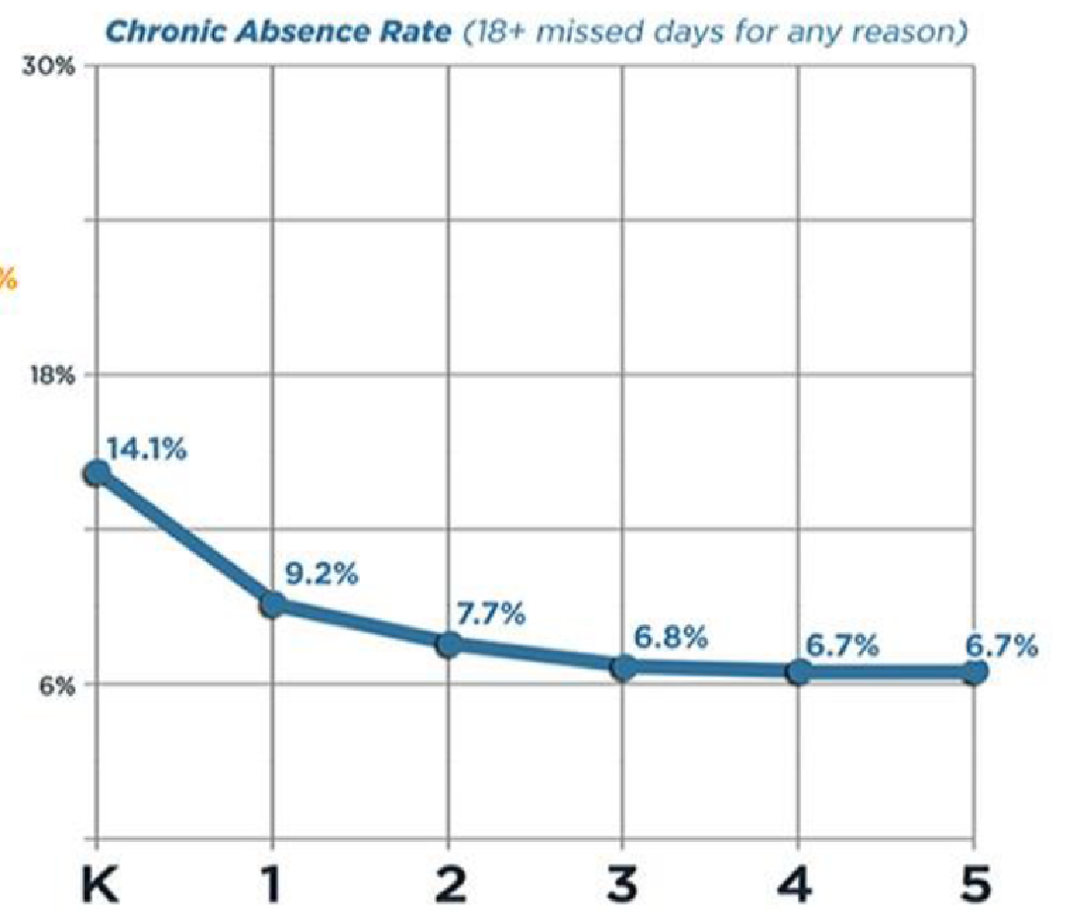

TCE’s support, combined with investments from other local and regional grantmakers, allowed key districts throughout the state to embark on the work. These innovators now serve as inspiring examples proving that chronic absence can be reduced and worth the investment, especially since better attendance in California increases a district’s allocation of state funds. A growing number of local and county superintendents as well as school board members are now helping to make reducing chronic absence, starting in the early grades, a priority. The California School Boards Association has played an especially critical role by helping spread the word statewide through its conferences and addressing the issue in a model school board attendance policy.

*California draws upon national and local research to make the case*

While champions in California have been able to draw upon national research to make the case, a major challenge has been the lack of statewide data because attendance is not tracked as part of the state’s longitudinal student data system. To compensate, the Attorney General’s office used data from a subset of districts to estimate that 250,000 elementary-age children were chronically absent in the 2013-14 school year. This analysis revealed that the highest levels were in kindergarten.

A [study](http://www.attendanceworks.org/wordpress/wp-content/uploads/2010/12/ASR-Mini-Report-Attendance-Readiness-and-Third-Grade-Outcomes-7-8-11.pdf) of the impact of chronic absence on young children in the San Francisco Bay Area has been an especially key resource. It found that only 17% of students chronically absent in both kindergarten and first grade read proficiently by the end of third grade. These results have been used to convey why chronic absence matters throughout California as well as nationwide.



**Map Chronic Absence:** *Which students, schools and districts appear to be most affected by chronic absence? How much of a problem is it in the early grades? Is information on chronic absence shared? If so, how?*

Because attendance is not included in its longitudinal student data system, the California Department of Education (CDE) does not yet have the ability to examine data showing differences in levels of chronic absence across grades, student populations or schools and districts. But this situation is beginning to change. When the Local Control Funding Formula was passed in 2013, it required local districts to submit plans including data on chronic absence (defined as missing 10% or more of the school year) for each school as a measure of accountability for pupil engagement.

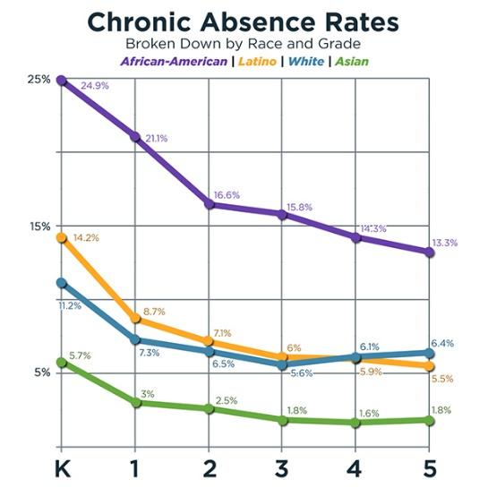The extent to which districts have calculated and shared this data, however, varies tremendously. Some districts produce and regularly distribute reports on the levels of chronic absence to site administrators overall and by school, while others have yet to determine chronic absence rates.

As discussed previously, the California Attorney General’s office uses data from a subset of districts to estimate statewide chronic absence rates. In 2014, the Attorney General’s office found profound differences in the rates of early chronic absence by ethnicity. black elementary students were 2.5 times more likely than white students to be chronically absent, with rates somewhat elevated for Latino children, as well. About 90% of students with severe attendance problems came from low-income families.

**Unpack Chronic Early Absence:** *What is known about factors that contribute to chronic early absence? What is known about health-related factors?*

Currently, the job of unpacking chronic absence is largely left to local school districts and schools. Available data suggest that physical and mental health concerns and poverty-related challenges impact chronic absence, especially among black students, who experience the highest levels of absenteeism. In 2011, 38.1% of black students ages 0-6 were living in poverty, more than 14.9 percentage points above the state average.[4] Black students, who are the most likely to experience chronic absence, are also twice as likely to have asthma,[5] and research also reveals that Latino and black students are significantly less likely to have visited a dentist.[6] A [study](http://www.attendanceworks.org/wordpress/wp-content/uploads/2011/03/CHIimproves-pdf-school-days-missed-March-2007.pdf) conducted by the Santa Clara Children’s Health initiative found that having health insurance improved school attendance. Meanwhile, according to Children Now, 26% of California’s low-income children under age 18 are uninsured.



**Learn from Positive Outliers:** *Have positive outliers been identified? How do they inform our work?*

In California, the best statewide mechanism for identifying promising practices is the annual [Model School Attendance Review Board (SARB) Recognition Program](http://www.cde.ca.gov/ls/ai/sb/modelrecognition.asp), which identifies and recognizes results-based school attendance improvement programs at the district or county level. SARBs were established by the California Legislature to bring together school staff and community members from a broad array of agencies and disciplines to find solutions to school attendance problems and divert students from entry into the juvenile justice system. The goal of the Model SARB Recognition Program is to find outstanding and innovative programs that will serve as models for other SARBs in the state. Initially focused primarily on programs addressing truancy and dropout rates, the Model SARB Recognition Program began focusing on chronic absenteeism rates in 2012.

Insights gained about what works and what more is needed are used to constantly update the *SARB Handbook*. This guidance helps local SARBs understand that legal interventions should be used as a last resort after all appropriate school and community resources have been exhausted. It encourages a three-tiered approach that begins with positive attendance activities before turning to early intervention activities, and then employing intensive intervention, with court support if needed. It also helps local SARBs reach out to community partners to ensure a strong inter-agency approach.

Local districts also have found ways to celebrate and learn from positive outliers that maintain strong attendance rates despite challenging conditions. For example, in Oakland the district and its community partners held a celebration to honor schools that had significantly reduced chronic absence levels and then held a panel with principals to share effective strategies. The work of these schools was also documented in this publication from the Oakland Achieves Partnership: [Attending School Every Day: Making Progress, Taking Action](http://oaklandachieves.files.wordpress.com/2014/09/oakachattendancefinal.pdf) in Oakland Schools.

California has the opportunity to take stock of how it might also leverage health-related initiatives that demonstrate an impact on improving school attendance. For example, the [Virtual Dental Home System](http://www.dental.pacific.edu/Community_Involvement/Pacific_Center_for_Special_Care_(PCSC)/Innovations_Center/Virtual_Dental_Home_System_of_Care.html) developed by the University of the Pacific offers a promising approach to reducing absences due to poor oral health. Meanwhile, the Long Beach Alliance for Children with Asthma offers an impressive model for how to use a combination of direct services and advocacy to reduce childhood asthma. In Kings County, the local SARB has partnered with [Kings County Behavioral Health](http://www.kingscountybehavioralhealth.com/outreach-materials.html) to provide intensive support and parenting classes for families with persistent attendance problems related to behavioral health or lack of parenting skills. Drawing on the collective experience of ally organizations and its own membership, the California School-Based Health Alliance crafted [online resources](http://www.schoolhealthcenters.org/healthlearning/chronicabsence/chronicabsenceresources/) summarizing effective practices and approaches that school clinics use to ameliorate chronic absence.



**Step 5: Embed Action into Existing Work and Initiatives:** *How can relevant reforms and cross-sector initiatives be leveraged to promote action?*

Attention to chronic absence is advancing rapidly because it has been successfully embedded into a variety of existing work and initiatives and is not seen just as a separate body of work. Below is a list of a few of the key efforts underway:

**Back-to-School Activities:** Back-to-school activities offer opportunities to encourage action, especially given the positioning of September as Attendance Awareness Month by multiple state leaders and agencies. The CDE uses the lobby of its Sacramento headquarters for a major display on attendance during the month of August, with a follow-up letter to all district administrators encouraging them to participate in Attendance Awareness Month activities. In 2014, the CDE, the Office of the Attorney General, the secretary of Health and Human Services and Assemblywoman Shirley Weber held a news conference heralding the importance of reducing chronic absence and sharing a proclamation declaring September as Attendance Awareness Month in the legislature. The Office of the Attorney General times its annual release of [In School + On Track](https://oag.ca.gov/truancy) to coincide with September’s activities. Chief Justice Tani Cantil-Sakauye sent a [letter to Juvenile Court judges](http://www.attendanceworks.org/wordpress/wp-content/uploads/2011/05/Attendance-Awareness-Month-Chief-Justice-letter.pdf) urging them to pay heed to student attendance and partner with schools to reduce chronic absence. In 2014, more than 50 communities participated in Attendance Awareness Month, and the number is close to 80 in 2015. About 50 local and county school superintendents are part of a nationwide Call to Action for superintendents.

In 2015, California has an additional opportunity to leverage back-to-school activities to address health needs that can pose barriers to getting to class. Recognizing the critical importance of ensuring that students have access to health care and the role that schools can play in disseminating information, California passed a law (AB 2706) requiring schools to provide information to families about their health coverage opportunities and enrollment assistance starting this year. A statewide campaign, [ALL IN for Health](https://d3n8a8pro7vhmx.cloudfront.net/allincampaign/pages/188/attachments/original/1435774570/AB2706.pdf?1435774570), has made it easy for schools to do what is needed as part of back-to-school activities.

State Superintendent Torlakson has continued to send strong messages, such as [this letter](http://www.cde.ca.gov/nr/el/le/yr15ltr0821.asp) to superintendents in the state, encouraging strategies to reduce chronic absence and to take advantage of available resources.

**The Local Control Funding Formula:** One of the most sweeping reforms to affect the California landscape has been the Local Control Funding Formula of 2013. By requiring every district in the state to address chronic absence as a key accountability measure, the state has shifted the metric from the sidelines to the center of many district and school reforms. Districts must report on baseline chronic absence data and how they will improve attendance as part of a Local Control Accountability Plan that must be submitted to their county office of education.

Leveraging the potential of this legislation, however, requires building the capacity of districts to calculate the data and intervene with students and schools showing high rates of absenteeism. A 2014 study led by Fight Crime: Invest in Kids and Children Now found that less than 20% of districts had calculated baseline data on chronic absence. Results from a new 2015 study will soon be released as part of the Attorney General’s new In School + On Track report.

In the meantime, the California Department of Education—in partnership with the California County Superintendents Educational Services Association, the CDE Foundation, Attendance Works and the Region IX Equity Assistance Center at WestEd—has begun training county offices of education to help districts calculate and monitor chronic absence using a mix of in-person and virtual interactions along with easy access to online tools and materials.

**School Improvement and NCLB Waiver:** A natural opportunity for addressing chronic absence is embedding in annual plans for school improvement. Districts can foster attention to attendance by providing data, technical assistance and information to help school sites understand chronic absence and how to address it. School plans are usually submitted to districts in March or April. This information can then be incorporated into a district’s overall Local Control Accountability Plan due to the county office of education by July 1.

Among the eight California school districts (see [coredistricts.org](http://coredistricts.org/).) that jointly applied for a waiver from the federal No Child Left Behind (NCLB) requirements, addressing chronic absence is even more of an explicit mandate. Chronic absence is one of the nonacademic measures included in the School Quality Improvement Index, which will be used to assess adequate yearly progress for their schools.

**School Discipline Reform:** In California, reforming school discipline has become a priority, especially given concerns over the disproportionately high levels of suspensions and expulsions pushing youth of color out of school. These concerns have led to greater adoption of initiatives that focus on alternatives to punishment and push-out, as well as positive behavioral interventions and supports. As a result, the number of students being suspended or expelled in California has declined sharply, as more schools and districts put into place measures designed to keep young people in the classroom and learning. Among older students, such efforts reduce chronic absence because suspensions are a form of absence. There is growing interest in developing strategies to adjust school climate efforts so they pay explicit attention to preventing and addressing absences along with more visible forms of problematic behavior.

**Community Schools and School-Based Health Care:** California also has a long history of establishing schools as a hub of services and supports from public agencies and communities. Chronic absence can serve as a unifying goal, an effective tool for resource allocation and an easily understandable measure of progress and success. Organizations such as the Partnership for Children & Youth and the California School-Based Health Alliance have helped integrate chronic absence into these initiatives by sharing information about chronic absence with their members and adding it to their technical assistance and materials.



Download the full report: *Mapping the Early Attendance Gap: Charting a Course for School Success*

**http://www.attendanceworks.org/research/mapping-the-gap/**

1. California Department of Education
2. KIDS COUNT Data Center, Annie E. Casey Foundation
3. Additional CAAP participants include the Alliance for Boys and Men of Color, Bay Area Council, California Family Resource Association, California School Boards Association, California School-Based Health Alliance, California State PTA, Campaign for Grade-Level Reading, Children’s Defense Fund–California, Ed Trust West, Families in Schools, Fight Crime: Invest In Kids California, Los Angeles Chamber of Commerce, as well as staff from the California Department of Education, Office of the Attorney General and California Department of Public Health. Some members participate for information exchange purposes only and do not participate in lobbying activities.
4. RACIAL/ETHNIC DISPARITIES–A DATA-INFORMED PERSPECTIVE, California Department of Alcohol and Drug Programs, June 2013
5. See <http://www.childhealthdata.org/browse/survey/results?q=2400&r=6&g=456>
6. Haves and Have-Nots: A Look at Children’s Use of Dental Care in California, California Health Care Foundation 2008. http://www.chcf.org/~/media/MEDIA%20LIBRARY%20Files/PDF/D/PDF%20DentalDisparitiesSnapshot07.pdf